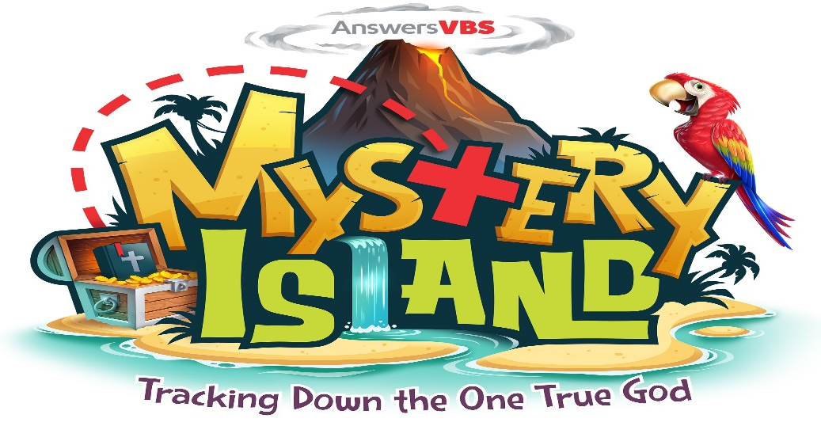

VBS
June 15th-June 19th

We are going all out this year, creating a tropical island, complete with colorful scenery of islands and ocean floors, awesome snacks, mind blowing science projects, interesting arts & crafts projects and parrot led games all designed to show children the awesomeness and greatness of the One True God.
VBS is a little different this year. VBS will be Monday - Friday this year and will be held in the afternoon from 1:30-4:30. We are looking forward to growing this program in the community and are actively working to “get the word out” about our exciting program.
This cannot happen without your help. We are still in need of volunteers to serve in various areas. If you are not interested in or able to physically help with VBS, please consider donating items to help put on this fantastic event. If you would like to donate to help with VBS purchases, please indicate VBS on your donation
Below is a list of supplies needed over the next few months. Please check the list often, as it will be updated on a regular basis. If you have questions, please contact Steve Patelski at s.patelski@mchsi.com or Megan Ault at daylaj@gmail.com. Thank you in advance for all your help and support with VBS. We have a great program in store for the children and we could not do this without your help. It is very much appreciated.

SUPPLIES NEEDED
Food items needed will be added to the list in May, closer to the event
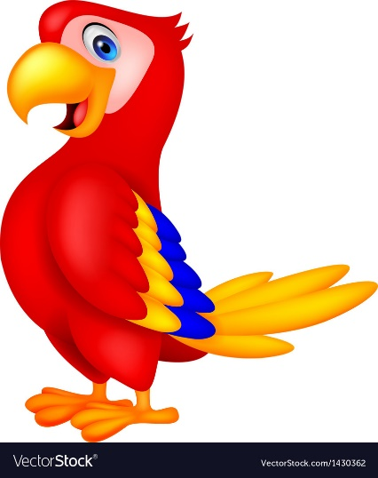

Items to collect
- Empty aluminum soda cans
- Empty plastic water bottles with lids
- Large plastic strawberry containers with the lids (These are the same containers for other fruits also).
- Paper grocery bags
- Cardboard boxes: all shapes and sizes
- Cardboard toilet paper rolls
- Cans of spray paint: brown or any bright colors that you may have lying around
- Small pieces of plywood, planks, pallets, etc.

Items needed for Science Experiments, Arts & Crafts, and Decorating
- 5 oz. Plastic tumbler cups (punch cups): 2 packages from Sam’s Club
- 9 oz. Clear plastic cups: 1 package from Sam’s Club
- 12 oz. Gray Paper Party Cups: 75 cups are needed. These can be purchased at Party stores or online.
- Pint Mason Jars (wide mouth, smooth sides): 1 case (12 jars)
- Baby food jars or glass jar of similar size (smooth sizes): 100 jars are needed. These can be purchase online in bulk at Amazon.com
- Boxes of food coloring: 5 Primary Colors, 1 box each of various colors (Neon, Pastels, etc.)
- Cooking oil: 2 bottles
- Alka Seltzer tablets: 1 container
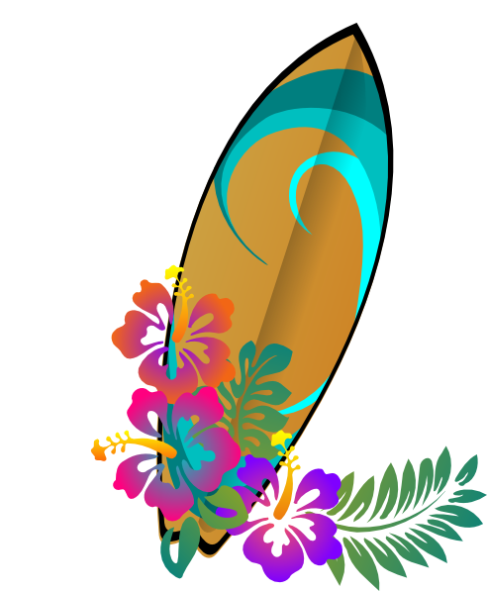
- Washable markers: 15 boxes (Primary Colors)
- Baby oil: 5 bottles
- Cotton balls: 2 packages
- Droppers or Transfer Pipettes: 20 pipettes (Natural Health in the Inner Perimeter shopping center has pipettes that are inexpensive)
- Transparency sheets – total of 100 sheets
- Grey card stock (or construction paper) (For Sharks!!!): 1 ream
- Cord for Necklaces (any color): 15 rolls
- Gold Glitter Tape (3/4 inches wide) – 5 rolls
- Dry Tempera Paint: (1) Forest Green, (1) Black, (1) Royal Blue, (1) Red, (1) Yellow
- Perler Beads: 2 bags or containers
- Mini craft bells (the shape needs to be an actual bell shape. These can be ordered on Amazon): 225 bells are needed
- Mini suction cups with hooks: 75 suction cups are needed
- Wood Beads (Medium size-all the same size): 5 packages
- Twine: 2 Rolls
- Wiggly eyes (various sizes): 1 large, 5 medium, 3 small
- 1-inch foam crosses
- Crystals or gems (Each bag needs to be the same size and shape): 2 bags each, small, medium and large
- Clam or Scallop shells: 75 shells needed (if they have holes drilled in the top that would be perfect)
- 5 Styrofoam coolers
- Gold Thumbtacks: 2 packages
- Pony Beads: various colors, and translucency
- Assorted Beads: various sizes, shapes, colors, and translucency
- Spray paints: brown, gray, various bright colors
- Metallic fringe curtain (both straight and curvy): (6) Blue, (6) Green, (3) Red, (2) Black
- Iridescent fringe curtain (both straight and curvy): (6) Blue, (3) Red, (1) Orange, (1) Gold/Yellow
- Metallic red fringe curtain (both straight and curvy): (3)
- Iridescent orange or yellow fringe curtain (both straight and curvy): (3)
- Iridescent black fringe curtain
- Cabana roof thatch decorations (or raffia trims) – 3
- Kiddie pools (plastic): 5
- Bags of Play Sand: 25
- Spray foam (insulation foam): 6 cans
- Fluorescent Paints: Bright colors (Greens, yellows, pinks, blues, purples, oranges)

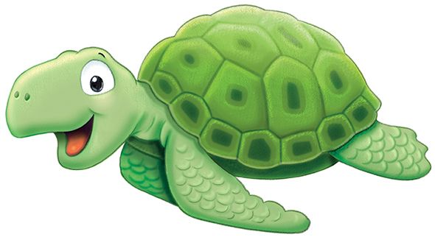
Things we need LOTS and LOTS and LOTS of:
- Floral twine
- Brightly colored tissue Paper (lots and lots)
- Pool Noodles – various colors and sizes
- Coffee filters
- Glue dots
- Plastic gems and sequins
- Treasure chest necklaces, plastic coins, kids costume jewelry (rings, tiaras, etc.), anything that would fill up treasure chests
- Plastic tablecloths in various shades of blues and greens, 10 black, 4 white
- Cardboard Boxes
- Construction paper: brightly colored
- Rolls of brown craft paper
- Tape: especially 2-sided tape (just keep them coming), duct tape (2) rolls

